**SAVEETHA SCHOOL OF ENGINEERING**

**CAPSTONE PROJECT**

**Network Topology and Congestion Minimization using Cisco**

**Packet Tracer**

**NAME: Sasi Kumar. S**

**REGISTER NUMBER:** 192324 254

# COURSE CODE: CSA0747

**COURSE NAME:** Computer Network for IOT

**Introduction:**

This project aims to design a network topology using Cisco Packet Tracer, incorporating routers, switches, PCs, and servers. The network simulation will implement congestion minimization techniques such as traffic shaping, Quality of Service (QoS) policies, and link optimization. The objective is to evaluate the network’s performance under different traffic loads and mitigate congestion for smoother network operations.

**Objectives:**

Design a network topology that includes multiple devices such as routers, switches, PCs, and servers.

Configure the workstations manually with IP address, subnet mask, default gateway, and DNS server.

Implement congestion minimization strategies, including traffic shaping and QoS policies.

Simulate network traffic and assess network behavior under different congestion scenarios.

**Network Design:**

The network consists of the following devices:

3 Routers: Serving as the core of the network for directing traffic.

4 Switches: Connecting multiple end devices, such as PCs and servers.

3 PCs: End devices configured with IP addresses for testing connectivity.

1 Servers: Providing network services such as DNS and web hosting.

**IP Allocation:**

Router1: 192.168.10.1

Router2: 192.168.20.1

Router3: 192.168.50.1

PC0: 192.168.10.2, PC1: 192.168.10.3

Server1: 192.168.50.2

The design follows a hierarchical structure where the routers form the core of the network. Each router is connected to multiple switches, and each switch connects to PCs and servers for better segmentation of traffic.

**Manual Configuration of Workstations:**

Each workstation is manually configured with the following:

**IP Address:** Unique IP assigned to each device based on its segment (e.g., PC0 has 192.168.10.2).

**Subnet Mask:** Standard mask of 255.255.255.0 for all devices.

Default Gateway: Set to the IP address of the router on the same network segment (e.g., 192.168.10.1 for PC0).

**DNS Server:** The server IP address (e.g., 192.168.50.2).

**Congestion Minimization Techniques:**

To minimize network congestion and optimize performance, the following techniques are employed:

Traffic Shaping: Limits the data rate for traffic flows, ensuring that critical services get adequate bandwidth and preventing network overloading.

QoS (Quality of Service): Prioritizes certain types of traffic, such as VoIP or video streams, ensuring that these types of traffic are less affected by congestion.

Link Optimization: Improves the performance of connections between routers and switches by optimizing bandwidth allocation or using techniques like link aggregation.

**Simulated Network Traffic:**

The simulation environment in Cisco Packet Tracer allows us to generate network traffic, test connectivity, and observe congestion:

**Traffic Generators**: Used to simulate HTTP, DNS, and FTP traffic across the network.

**Traffic Patterns:** Configured to represent different real-world scenarios, such as peak usage periods.

**Packet Generation Rates:** Modified to assess the network's capacity to handle increasing data loads.

**Testing and Verification:**

Testing was conducted using:

**Ping Tests:** To check connectivity between devices and verify the IP address configuration.

**Traceroute:** To identify the path packets take through the network, helping to locate any congestion points.

**QoS Monitoring:** Simulation of real-time traffic to verify that high-priority packets (such as voice and video) are given preference in the network.

**Network Design:**

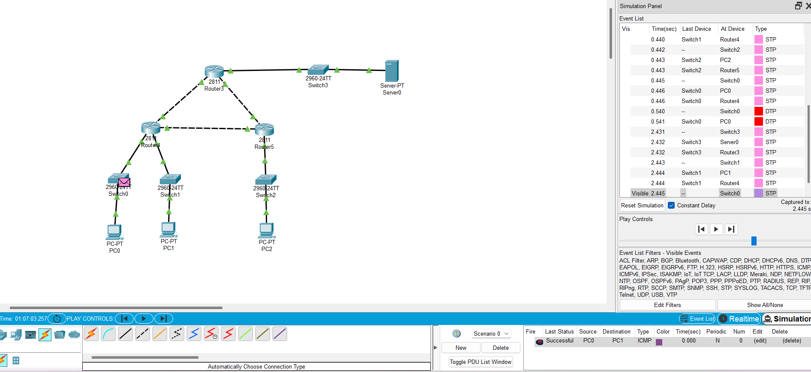

**Conclusion:**

By utilizing Cisco Packet Tracer, this project successfully simulates a complex network design with routers, switches, PCs, and servers. The implementation of traffic shaping, QoS, and link optimization techniques effectively mitigates congestion. The simulated traffic patterns demonstrated the ability of the network to handle various loads and maintain optimal performance during peak congestion periods.